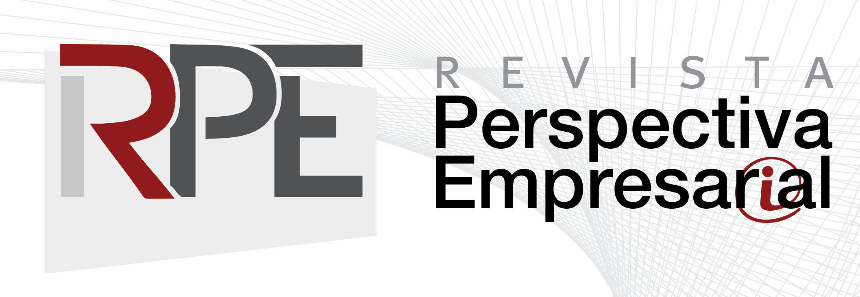

AUTHORS’ DECLARATON OF COMMITMENT

This form must be filled out and sent to the Journal. If the paper is not accepted for publication, this document will have no legal effect and will be considered null and void.

Paper title:

It is stated that:
- The content of the paper has not been published in another journal, nor has it been, or will it be, submitted for publication to another journal during the review and acceptance process.
- Responsibility is assumed for all concepts and opinions expressed in the paper. Fundación Universitaria CEIPA is not responsible for the judgments and concepts issued in the published paper.
- Commitment is made to comply with the indications and suggestions of the peer reviewers, if intention to publish the material in this Journal remains.
- Commitment is made to acknowledge the publication credits to this Journal when making subsequent use of the published material.
- The contents of the Journal are distributed under the license Creative Commons Reconocimiento-NoComercial-CompartirIgual 4.0 Internacional.
.
This license allows others to distribute, mix, adjust and build upon your work, even for commercial purposes, as long as you are credited as the author of the original creation.
- It is fully understood that the process of review and acceptance of the material submitted may take an average of four months, and that its receipt does not imply its automatic approval and publication.
- It is guaranteed that only those persons who have contributed intellectually to the development of the work appear as authors and are the owners of the referred article.
- Commitment is made to complete the CV form of the Journal.

In witness whereof, this statement is signed on this ______ day of ____________20___.

Author: |  | ID No: |  | Signature:
Author: |  | ID No: |  | Signature:
Author: |  | ID No: |  | Signature:

